Place Value

 | Millions | Hundred Thousands | Ten Thousands | Thousands | Hundreds | Tens | Ones | Decimal Point _______ | Tenths | Hundredths | Thousandths | Ten-Thousandths | Hundred-Thousandths | Millionths
Order
1
2
3
4
5
6
7
8
9

1-6 - Order the decimals least to greatest in the table above.
254.001, 23456.789101, 58.79, 2.9, 88410.02037, 4799.4321
7-9 - Order the decimals least to greatest in the table above.
7.2, 97.44, 8.4

Adding & Subtracting Decimals
HOW TO ADD AND SUBTRACT DECIMALS

When adding and subtracting decimals always line up the decimals!

3.8 – 2.14 3.8
-2.14 line up the decimals

Add a zero 3.80
if necessary -2.14

32.442 + 5.91 32.442
+ 5.91 line up the decimals

Add a zero 32.442
if necessary + 5.910

You Try It!

0.15 + 3.1 | 17.810 – 3.999
45.098 + 7.8994 | 25.1 - 3
103.98 + 4.6701  18.222 + 7.9942 | 49.320 - 35.2234  1876.3 – 187.63
Work Page

Multiplying Decimals
HOW TO MULTIPLY DECIMALS
Is multiplying with decimals the same as multiplying with whole numbers? ________
35 x 48 35  x48 280  +1400  1680 | 3.5 x 4.8 3.5  x4.8  280  +1400  16.80

So…how do we determine where the decimal goes?
____________________________________________________________________________________
__________________________________________

Steps to multiplying decimals:
- Estimate the answer.
- Stack the numbers vertically (ignoring the decimal) and multiply.
- Insert decimal point into the product by counting the digits behind the decimal/s.
or
Ask yourself, what the place value of the last digit is after the decimal for each factor – multiply those place values together and this tells you the place value of the decimals in the final product.

3.5 tenths 0.1
x4.8 $×$ tenths $×$0.1
280 Hundredths 0.01
+1400
16.80 Hundredths 0.01

12.5 x 6.33 = 79125 10 x 5.67 = 5670

0.591 1228 4.25
x 7.8 x 1.77 x .11
46098 217356 4675

You Try It!

25 $∙$ 0.4 | 1.201 $×$ 1.11
0.006(3.4) | 0.3 of 1.101
11.2 $∙$ 0.005 | 2(0.000006)

Work Page
DIVIDING WHOLE NUMBERS
HOW TO DIVIDE WITH WHOLE NUMBERS
Standard Algorithm:

Quotient
Dividend$÷$Divisor = Quotient Divisor Dividend

325 $÷$25 = | 013  5 325  -30  25  - 25  0

You Try It

696$÷$12 | 750$÷$15
744$÷$24 | 1000$÷$25

Work Page

Dividing Decimals

HOW TO DIVIDE DECIMALS
Standard Algorithm:

Quotient
Dividend$÷$Divisor = Quotient Divisor Dividend

0.13  3.25 $÷$25 = 25 3.25  $-$ 0__  32  $-$ 25_  75  $-$75  0 | 0 12.1  3.025 $÷$.25 = .25 3.025  $-$ 0__  30  $-$ 25_  52 $-5$0  25  - 25  0

You Try It

6.96$÷$12 | 7.50$÷$.15
.744$÷$2.4 | 10.00$÷$.25
35.7$÷$.17 | .484$÷$.22
Work Page
VOCABULARY
Decimal |  | a number in a number system based on 10, also known as the Base-10 system
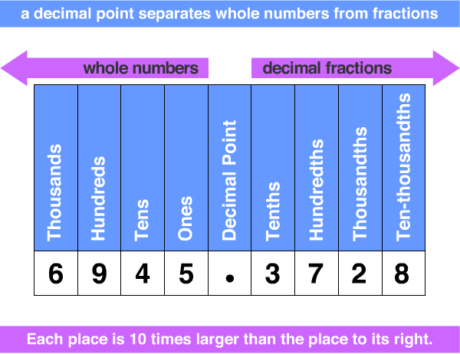
Place Value |  | • the value of a digit depending on its place in a number.
See chart above

Addend |  | • any number used to get the sum or total.
Minuend |  | • the minuend is the first number in a subtraction.
Subtrahend |  | • the subtrahend is the number taken away.
Algorithm | • a way of setting out a step-by-step mathematical procedure.  • a method used to find an answer.
EXAMPLE: Long multiplication steps or long division steps

Multiplication | • a mathematical operation where a number is added to itself a number of times.  EXAMPLE: 2 + 2 + 2 = 2 x 3 or 2, 3 times.
Division | • to divide or division is sharing or grouping  a number into equal parts.  • dividend: the number being divided.  • divisor or factor: a number that  will divide the dividend exactly.

