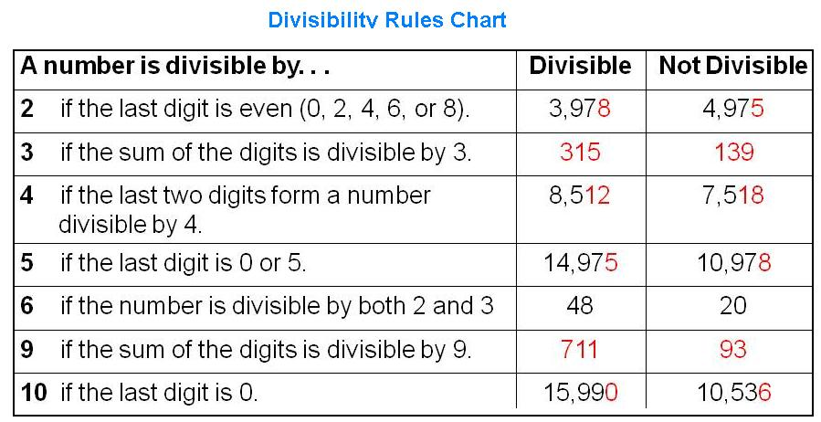
Divisibility Rules
Rules of Divisibility Song:
http://www.youtube.com/watch?v=K1N4zZndqMs

Mark each box that the number is divisible by.
Is it Divisible? | By  2 | By  3 | By  4 | By  5 | By  6 | By  9 | By  10
10
57
92
171
672
960
2385
11,160
Multiplying Fractions

$\frac{7}{10}×\frac{4}{5}$=

Multiply the numerators and the denominators.

$$\frac{7}{10}×\frac{4}{5}=\frac{7×4}{10×5}=\frac{28}{50}$$

Reduce if possible.

$$\frac{28÷2}{50÷2}=\frac{14}{25}$$

$$\frac{3}{8}×\frac{2}{6}$$

$$\frac{1}{2}∙\frac{4}{9}$$

$$\frac{1}{6} of 6$$

There are three ways to represent multiplication-: x, $∙$, of

$÷$Dividing Fractions$÷$
The Big Question when we are dividing:
How many times will the divisor fit into the dividend?
$$6 ÷ \frac{1}{2} = x$$
Dividend $÷$ Divisor = Quotient

How many groups of ½ are in 6 whole?

1 2 3 4 5 6

How many groups of 1/3 are in 5 wholes?
Draw a tape model?

Show it on a number line.

You went to Subway and bought a subway sandwich. You ate ½ of the sandwich and your three friends wanted to share the other half? How much of the subway sandwich will each person eat?

How much of the sandwich will you eat?

How much of the sandwich will your friends have to share?

How much of the sandwich will each of your friends get to eat?

Thank Mrs. McBride for your Subway Problem.

The Big Question when we are dividing:
How many times will the divisor fit into the dividend?
$$\frac{1}{2} ÷ \frac{1}{8} = 4$$
Dividend $÷$ Divisor = Quotient
In other words, how many $\frac{1}{8}$s are there in$\frac{1}{2}$?
Demonstrate your thinking in the tape diagram.

Using a tape diagram find the quotients:

$\frac{3}{4}÷\frac{1}{8}=x$

$\frac{1}{8}÷\frac{1}{4}=x$

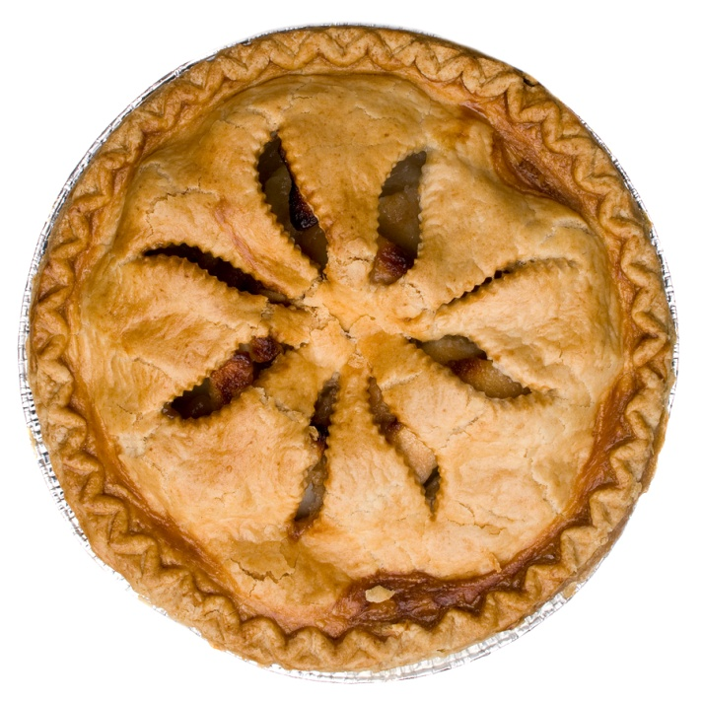
Mrs. Wade brought leftover pie to school. Her husband ate 1/3 of the pie. Mrs. Wade wanted to share the other 2/3 of the pie with her teacher friends. How many 1/6 servings will she have to share?

Let’s get mathematical
By using an algorithm!

We have figured out the division of fractions is dividing a part into other parts. Now that we understand that…it is time to learn the algorithm (aka – a specific equation).

You could say this is magic!
$$\frac{1}{8}÷\frac{1}{4}=x$$
Rewrite the problem to multiply by the reciprocal (turn the divisor upside down).
$$\frac{1}{8}×\frac{4}{1}=x$$

Reciprocals are when the product of two numbers equal one.
$$\frac{1}{4} ×\frac{4}{1}=\frac{4}{4}=1$$
So, the reciprocal of $\frac{1}{4}$ is $\frac{4}{1}$.

Practice Makes Perfect!!!

I can apply and extend my previews understanding of multiplication and division to divide fractions by fractions.

Apply what you have learned to the following word problems.

A recipe for a loaf of banana bread requires 2/3 cup of vegetable oil. You have 3 cups of oil. How many loaves of banana bread can you make with the oil?

How many ¼ inches are in ½ foot? Draw a diagram that models the problem.

A piece of rope $\frac{2}{3}$ yard long is cut into 6 equal pieces. How long is each piece in feet?

Write your own Story:
Write your own story to the following division problem:
3 ÷ 7
8 12

Pair share: Can your partner understand and solve this problem without you explaining it to him/her?

Vocabulary
Divisible | • can be divided evenly without leaving a remainder.
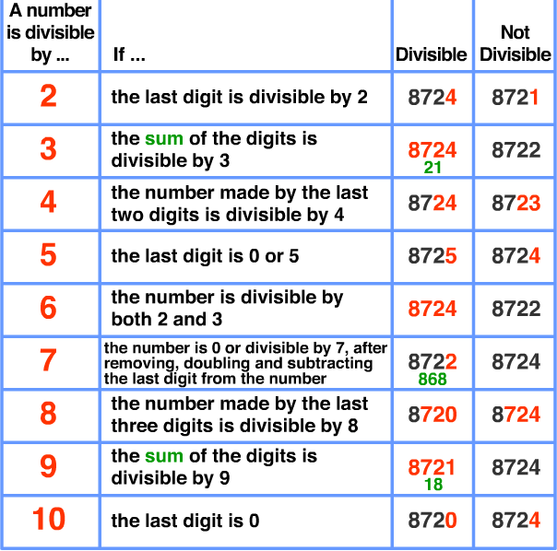
Examples:

Fraction | • any part of a group, number or whole.
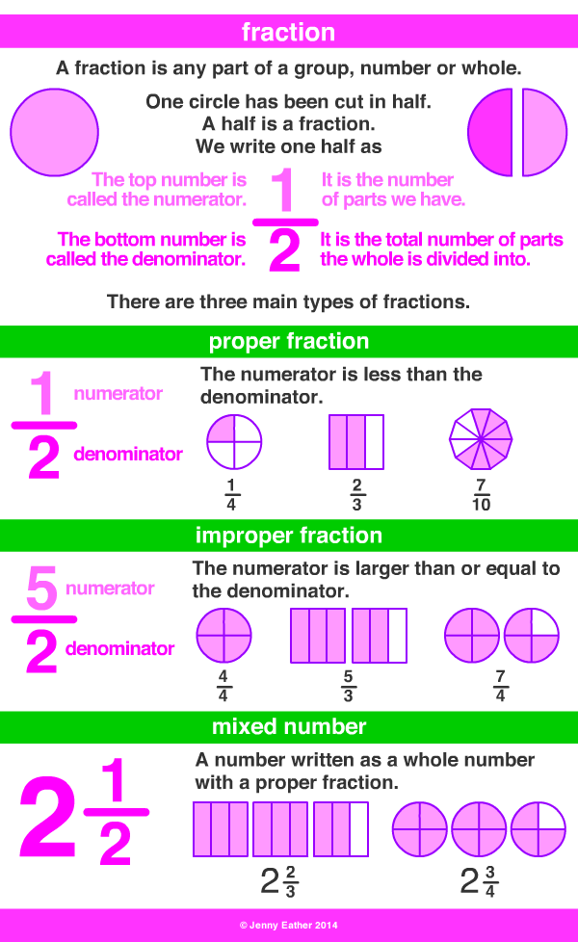
Numerator | • number above the line of a fraction, showing the number of parts of the whole
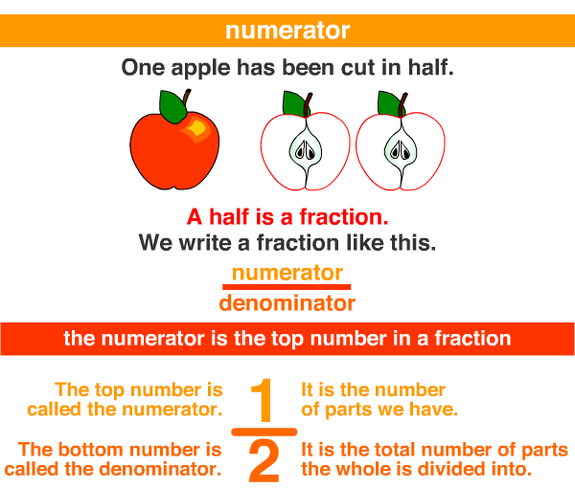
Denominator | • the bottom number in a fraction showing  the number of parts the whole is divided into.
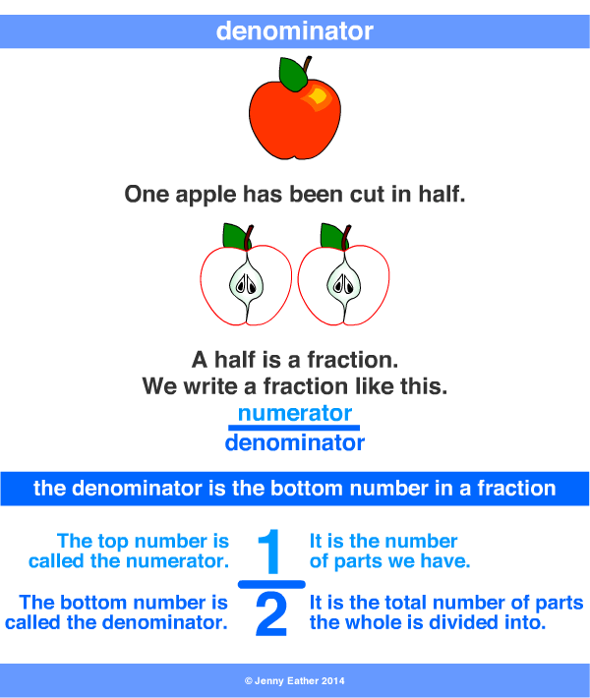

LCM/LCD  Lowest Common Multiple  Lowest Common Denominator | • the lowest common multiple of the denominators.  • the smallest number into which the denominators will divide exactly.
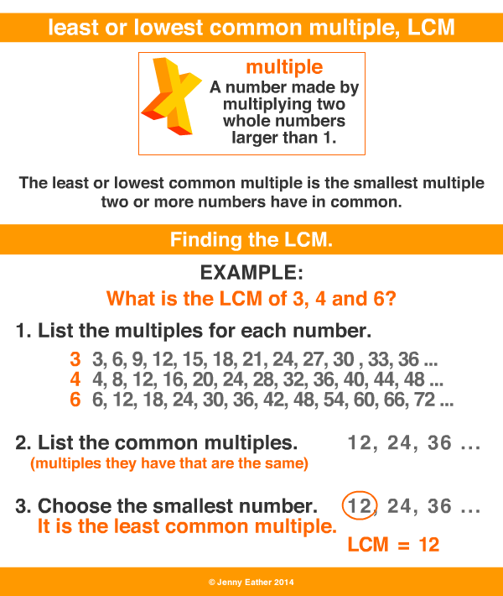
Common Denominator | • a common multiple of the denominators, that is, a number into which the denominators will divide exactly.
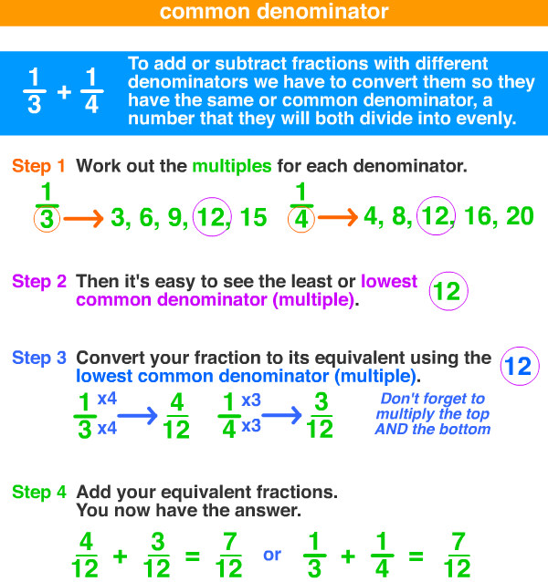

Quotient | • the number resulting from dividing one number by another, the answer.
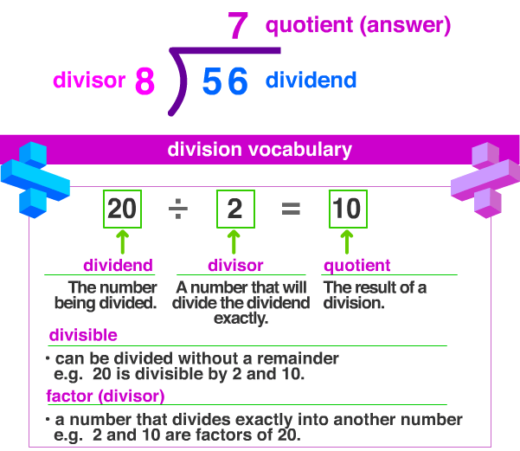
Dividend | • dividend: the number being divided.
Divisor | • divisor or factor: a number that will divide the dividend exactly.
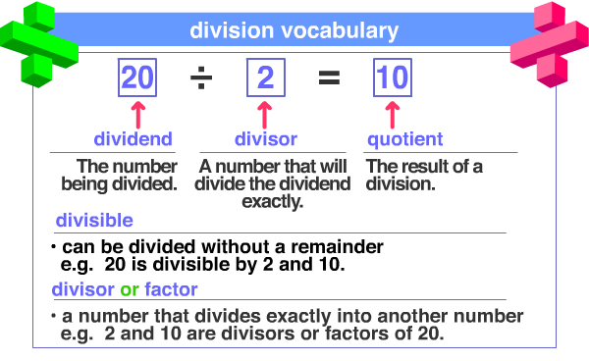

Reciprocal | • also called the multiplicative inverse.  • one of two numbers whose product is 1, n x n = 1.  • to get the reciprocal of a number,  divide 1 by the number.
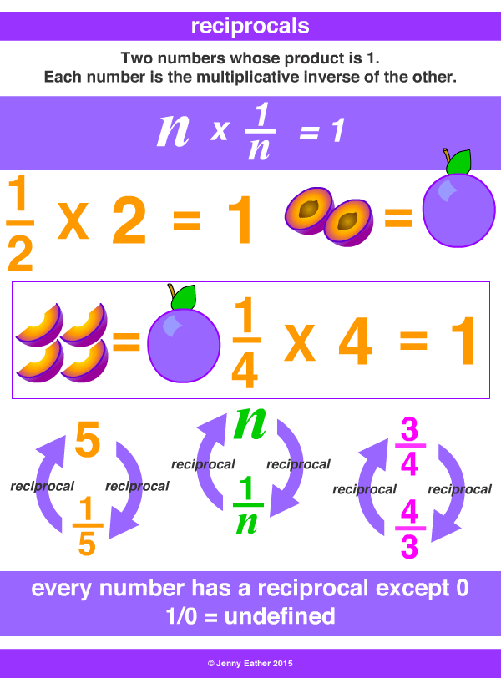

http://www.amathsdictionaryforkids.com/

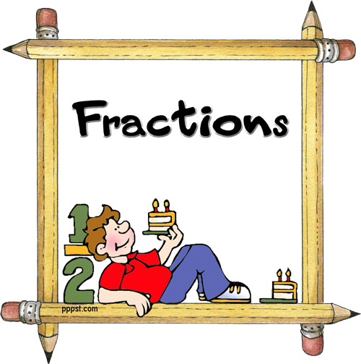
Number Systems

Name______________________________

Period_______

Teacher____________________________

I Know and Can Use the Divisibility Rules to Help Me Factor Out Math

o I have memorized the rules for 2, 3, 4, 5, 6, 9, 10

I Can Apply and Extend My Previous Understanding of multiplication and Division to Divide fractions by Fractions.

o I understand how to interpret/read and compute/solve quotients of fractions. 6.NS.1
o I can solve word problems involving division of fractions by fractions. 6.NS.1
o I can use visual fraction models and equations to represent fraction problems. 6.NS.1

