Greatest Common Factor
The GCF (_________ __________ _______) of two or more numbers is the __________ _________ the numbers have in common.

List the Factors of the following numbers:

24

36

Factor Tree
24 36

48 72

Upside Down Division

24 36

48 72

When do we use the GCF?
- to divide things into smaller pieces
- to equally distribute sets of items into their largest grouping:
  - to figure out how many people we can invite
  - to arrange something into rows

Example:
Samantha has two pieces of cloth. One piece is 72 inches wide and the other piece is 90 inches wide. She wants to cut both pieces into strips of equal width that are as wide as possible. How wide should she cut the strips?
What do I know?
- The pieces of cloth are 72 and 90 inches wide.
What do I need to find out?
- How wide should she cut the strips so that they are the largest possible equal widths.

What is my plan?
- This problem can be solved using Greatest Common Factor because we are cutting or “dividing” the strips of cloth into smaller pieces (Factor) of 72 and 90 (Common) and we are looking for the widest possible strips (Greatest).
- I will find the GCF of 72 and 90

How wide should she cut the strips?

Least Common Multiple

The LCM (__________ ___________ ___________) is the _______________ ______________that is a _____________ of two or more numbers.

Find the LCM
6

9

6 9

Find the LCM

4, 8, 12, LCM =

5, 7, 3 LCM=

LCM Problems may be asking you:
- about an event that is or will be repeating over and over.
- to purchase or get multiple items in order to have enough.
- to figure out when something will happen again at the same time.

Example:
Ben exercises every 12 days and Isabel every 8 days. Ben and Isabel both exercised today. How many days will it be until they exercise together again?

What do I know?
- Ben exercises every 12 days and Isabel every 8 days and they both exercised today.

What do I need to know?
- How many days is it until they will both exercise on the same day again.

What is my plan?
- This problem can be solved using Least Common Multiple because we are trying to figure out when the soonest (Least) time will be that as the event of exercising continues (Multiple), it will occur at the same time (Common).
- I will find the LCM of 8 and 12.

How many days will it be until they exercise together again?

Find the GCF and LCM of the following numbers:

8, 12  10, 15 | 25, 50  22, 33

Distributive Property

How do you find the GCF of two addends using the Distributive Property?
For example how do we write an equivalent expression for:

8 + 12
Any number can be written as a sum of two (or more) numbers:

20
1 + 19
2 + 18
3 + 17
4 + 16
5 + 15
6 + 14
7 + 13
A factor of a multiplication expression can be rewritten as the sum of two numbers:

3 X 15
3 x (10 + 5)

Parenthesis can be used to show part of an expression:

3 x (10 + 5) = 3(10 + 5)

3(10 + 5) = 3 x 15

If you want to write an equivalent expression for adding 36 + 60, you can use the distributive property:

Demonstrate how upside division can be a good strategy for finding an equivalent expression using the distributive property for 36 and 60.

Use the Distributive property to factor out the GCF from an addition expressions:

12 + 18 8 + 10

20 + 12 40 + 5

What Are Integers

An integer is a number that has no fractional part, and no digits after the decimal point. An integer can be positive, negative or zero. Includes:
• the counting numbers {1, 2, 3, ...},
• zero {0}, zero is not positive or negative
• and the negative of the counting numbers {-1, -2, -3, ...}
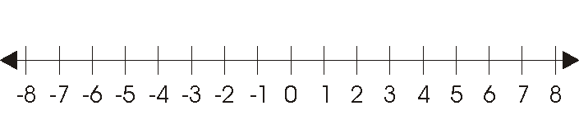
The farther right a number is on the number line, the greater (bigger) the number.

The farther left a number is on the number line, the lesser (smaller) the number.

Compare the following integers using <, >, or =.

-3____3
0____-20
64____-63
-10____9

A number line can be horizontal (laying down) or vertical (standing up). Can you think of when we use a number line that is vertical?

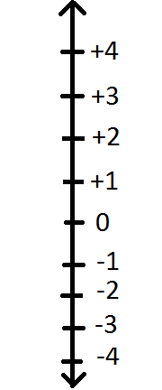

The higher a number is on the number line, the greater (bigger) the number.

The lower a number is on the number line, the lesser (smaller) the number.

Write the integer for the following:

7° below 0 ____ 100 feet above sea level____

A gain of 4 yards____ A loss of ten yards_____

1000 B.C.____ 2016 A.D.______
What are Opposite Values?

Opposite values are the opposite integer on a number line.

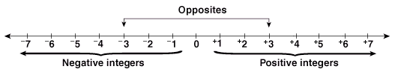

For example:
The opposite of 3 is -3 and the opposite of -7 is 7.

Give the opposite value for the following numbers:

-3 ___
15 ___
115 ___
0 ___

Does 0 have an opposite value?_______
Explain:

What is Absolute Value?

Absolute Value is the distance of a number from 0.

$\left|-6\right|=6$ $\left|4\right|=4$
6 units 4 units

Absolute Value is ALWAYS Positive!

A student was given the following absolute values. Determine whether his answers are written correctly with a yes or no. If the answer is no then explain why.

Yes or No Why Not?

$\left|-7\right|=$ _____ ______ ______________________________

$\left|25\right|=$ _____ ______ ______________________________

$\left|-100\right|=$ _____ ______ ______________________________

$\left|38\right|=$ _____ ______ ______________________________

Your Turn

The temperature at 3:00 PM was 22°. The temperature at 11:00 PM was 4° below zero. What was the change in temperature from 3:00 PM to 11:00 PM?

Show your work using a vertical number line:

COORDINATE PLANE
Label the following:

Quadrant I
Quadrant II
Quadrant III
Quadrant IV
Origin
Y-Axis
X-Axis
(+, +)
(+, -)
(-, -)
(-, +)

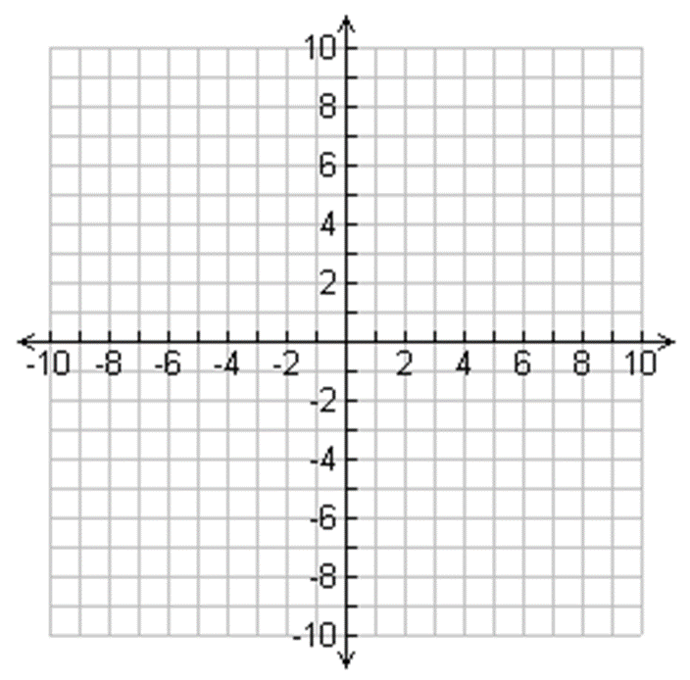

Coordinates:
Coordinates are a set of values that show an exact position.

On maps and graphs it is common to have a pair of numbers to show where a point is: the first number shows the distance on the x-axis (horizontal) and the second number shows the distance on the y-axis (vertical).

Coordinates are put in parentheses with a comma between each coordinate (x,y).

*Remember the x-coordinate is always first.

Label the x-coordinate and the y-coordinate:
(-3, 5) (7, 12) (5, -15) (-3, 0)

Graph the following coordinates:
*Always begin at the origin!

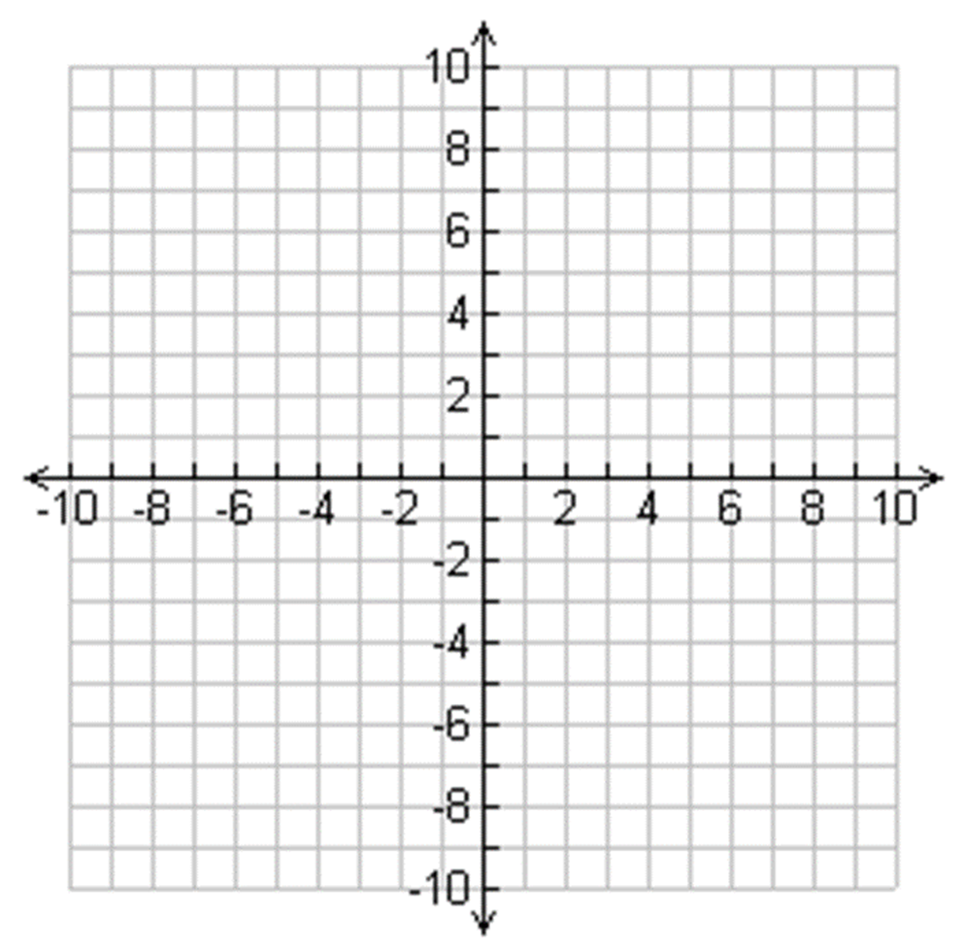
(4, 0) (0,0) (-5, -7) (-8, 6)

Vocabulary
GCF  greatest common factor |  | • the highest or greatest common factor that will  divide two or more other numbers exactly.
24 36

LCM |  | • the smallest number that is the multiple of  two or more other numbers.
24 36

Factor Tree | • a diagram used to identify the prime factors  of a composite number.

Integer
Positive | positive integer  • a whole number greater than zero, but  not a fraction or decimal fraction.
Negative | negative integer  • a number less than zero,  but not a fraction or a decimal fraction.  • written with a minus sign.
Opposite | opposite numbers  • two numbers having the same numeral but different signs.  EXAMPLE: -4, +4
Absolute Value | absolute value  • the absolute value of a number (x or -x) is just  the value of the numeral, ignoring the sign.  • the distance the number is from zero on the number line  written as lxl = x or l-xl = x, for example |-5| = 5.  EXAMPLES:  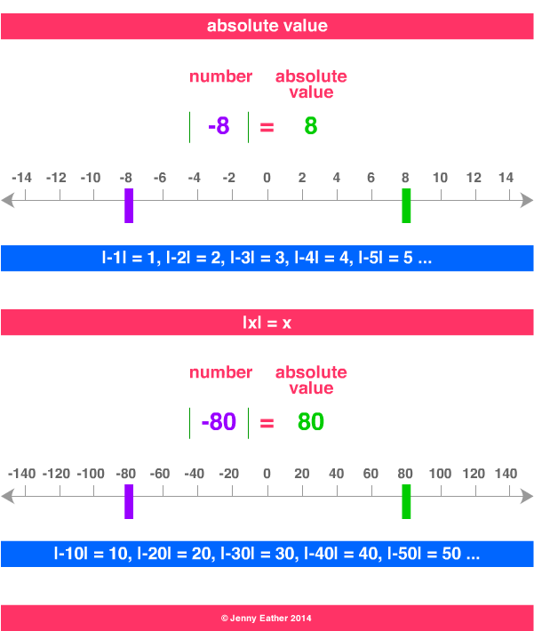

Distributive Property | distributive law, rule or property  • multiplying a number is the same as multiplying its addends by the number, then adding the products.  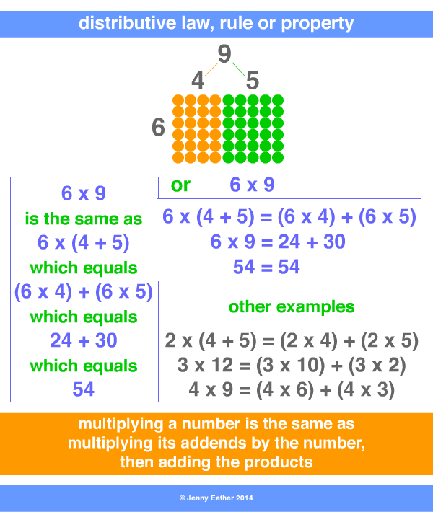
Coordinate Plane | coordinate plane or Cartesian plane  • a plane containing two perpendicular axes (x and y)  intersecting at a point called the origin (0,0).  • position is denoted using pairs of coordinates, e.g. (2, 4).  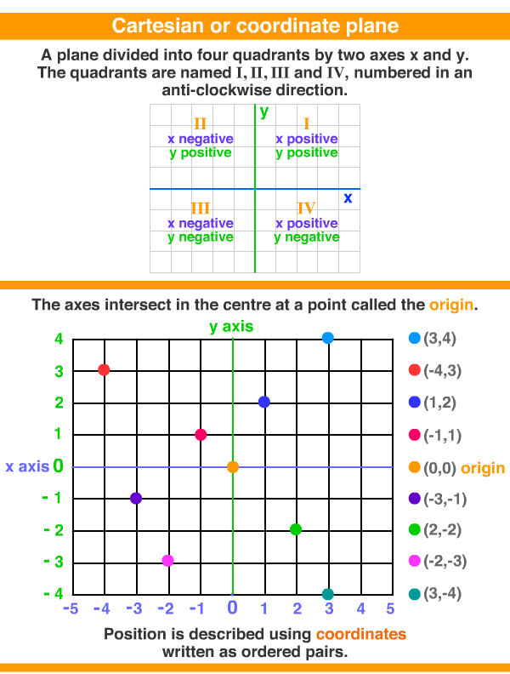
Quadrants
Origin | origin  • the point of intersection of the x and y axis  on a coordinate or Cartesian plane.  • the coordinates of the origin are (0, 0).  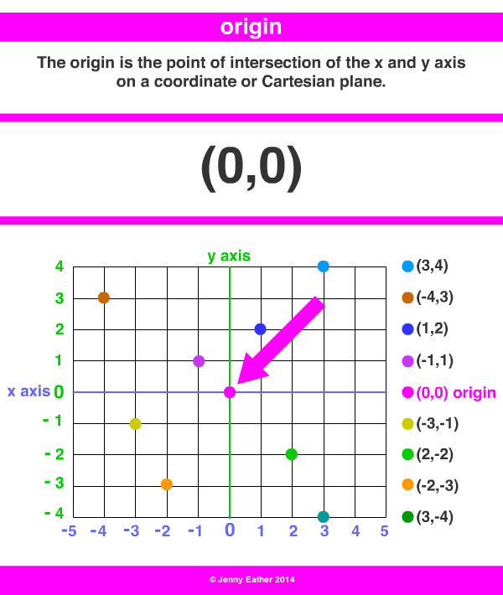
X - axis | x axis  • the horizontal axis of a graph.  x coordinate  • the position of a point according to the x axis.
Y - axis | y axis  • the vertical axis of a graph.  y coordinate  • the position of a point according to the y axis.
Ordered Pair | ordered pair  • a pair of numbers where order is important,  for example, (4, 6) is different to (6, 4).  • coordinates are written as ordered pairs of numbers  or letters and numbers.  • the first term is called the abscissa and  denotes the horizontal position.  • the second term is called the ordinate and  denotes the vertical position.  • used on coordinate planes,  grids or maps.
Points | point of intersection  • a point in space where lines intersect.  • often designated as P.
Coordinates | coordinates  • coordinates are written as ordered pairs of numbers  or letters and numbers.  • used on coordinate planes, grids or maps.  Grid

